Linear Regression - comp- active databases

Problem 1: Linear Regression
The comp-activ databases is a collection of a computer systems activity measures .
The data was collected from a Sun Sparcstation 20/712 with 128 Mbytes of memory running in a multi-user university department. Users would typically be doing a large variety of tasks ranging from accessing the internet, editing files or running very cpu-bound programs.
As you are a budding data scientist you thought to find out a linear equation to build a model to predict 'usr'(Portion of time (%) that cpus run in user mode) and to find out how each attribute affects the system to be in 'usr' mode using a list of system attributes.

DATA DICTIONARY:
-----------------------
System measures used:
lread - Reads (transfers per second ) between system memory and user memory
lwrite - writes (transfers per second) between system memory and user memory
scall - Number of system calls of all types per second
sread - Number of system read calls per second .
swrite - Number of system write calls per second .
fork - Number of system fork calls per second.
exec - Number of system exec calls per second.
rchar - Number of characters transferred per second by system read calls
wchar - Number of characters transfreed per second by system write calls
pgout - Number of page out requests per second
ppgout - Number of pages, paged out per second
pgfree - Number of pages per second placed on the free list.
pgscan - Number of pages checked if they can be freed per second
atch - Number of page attaches (satisfying a page fault by reclaiming a page in memory) per second
pgin - Number of page-in requests per second
ppgin - Number of pages paged in per second
pflt - Number of page faults caused by protection errors (copy-on-writes).
vflt - Number of page faults caused by address translation .
runqsz - Process run queue size (The number of kernel threads in memory that are waiting for a CPU to run.
Typically, this value should be less than 2. Consistently higher values mean that the system might be CPU-bound.)
freemem - Number of memory pages available to user processes
freeswap - Number of disk blocks available for page swapping.

Linear Regression
Linear regression is a way to identity a relationship between two or more variables. We use this relationship to predict the values for one variable for a given set of values of the other variables. The variable, which is used in prediction is termed as independent/explanatory/regressor variable. Linear regression assumes that the dependent variableis linearly related to the estimated parameters.

Y= c + mx

Objective:

- Understand what is Linear Regression and the motivation behind Linear Regression
- What is the best fit line and the concept of residuals of Linear Regression
- Least Square method to find Best Fit line of Regression.
- Gradient Descent method to find Best Fit line of Regression.

  - Read the data and do exploratory data analysis. Describe the data briefly. (Check the Data types, shape, EDA, 5 point summary). Perform Univariate, Bivariate Analysis, Multivariate Analysis.

Head Function
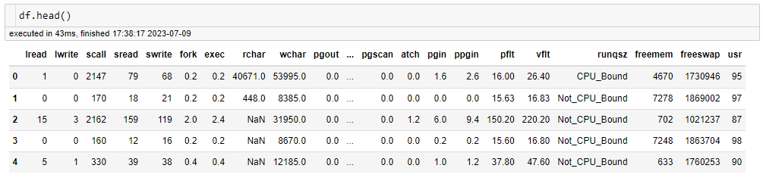

Shape Function
No of rows: 8192, No of Columns: 22
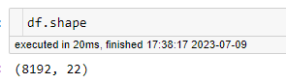
Duplicate Function
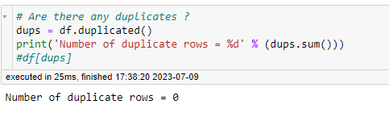
Describe Function
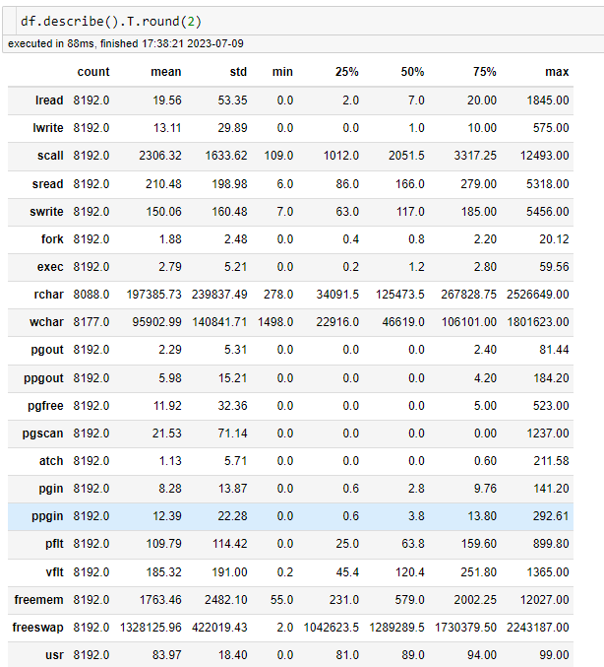
Info Function
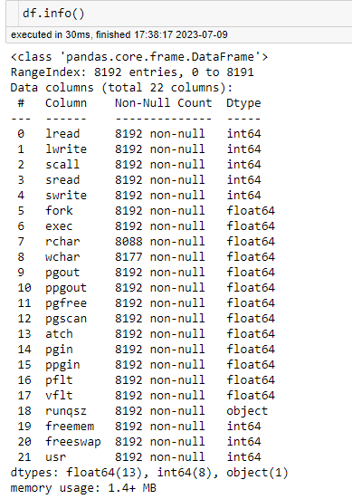
Null Function
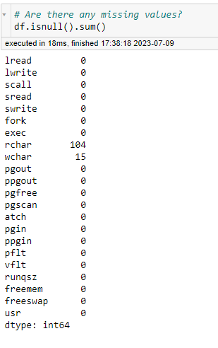

Summary:
- There are 8192 number of rows and 22 column in the dataset.
- There are 8 in int61, 13 in float64 and 1 in object present in the dataset.
- No duplicate records present in the dataset.
- Null value present in the dataset for rchar is having 104 rows and wchar is having 15 rows.
Univariate Analysis – Visualization of bar plot
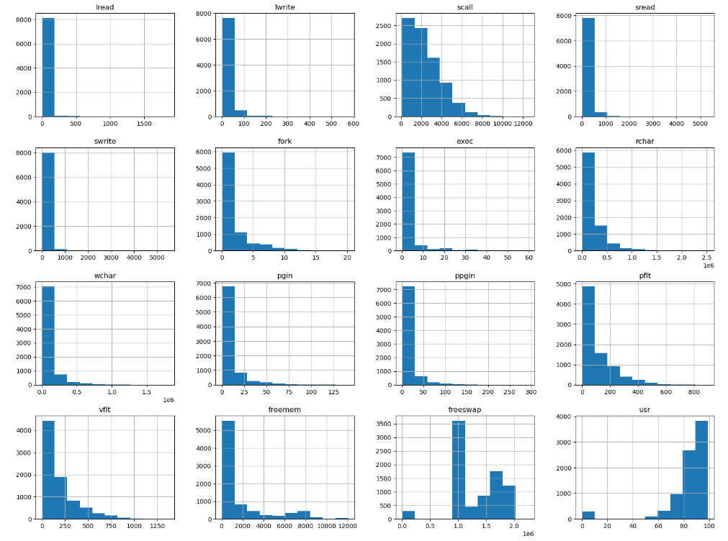
Bivariate Analysis
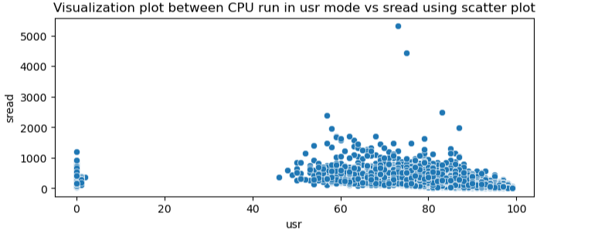

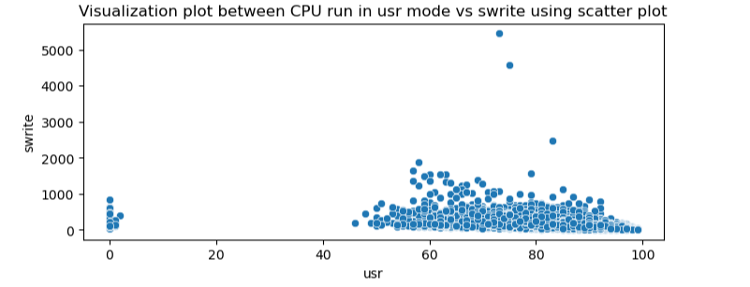

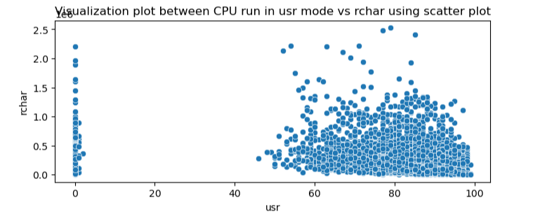

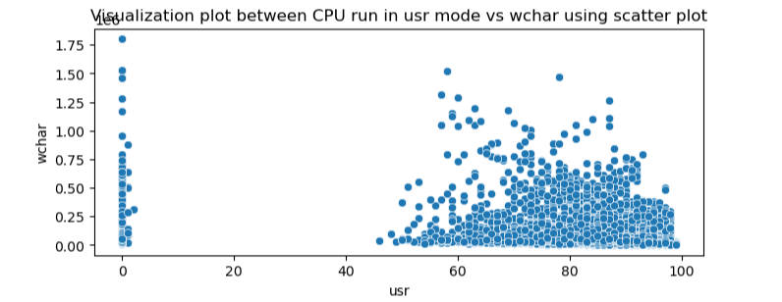

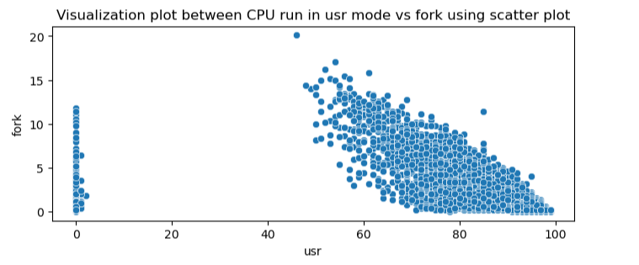

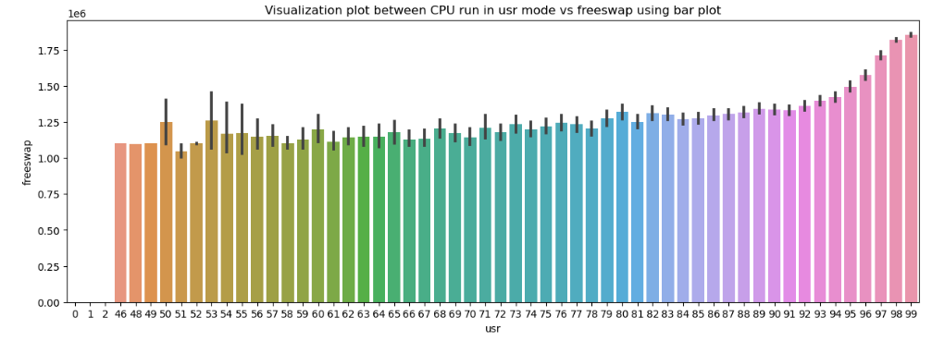

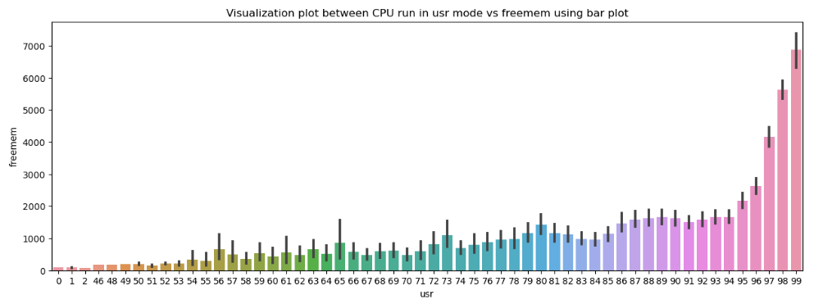

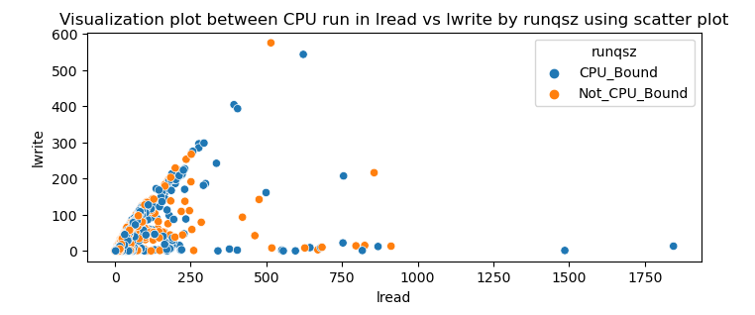

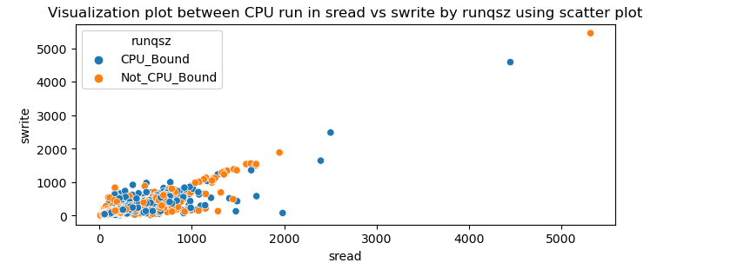

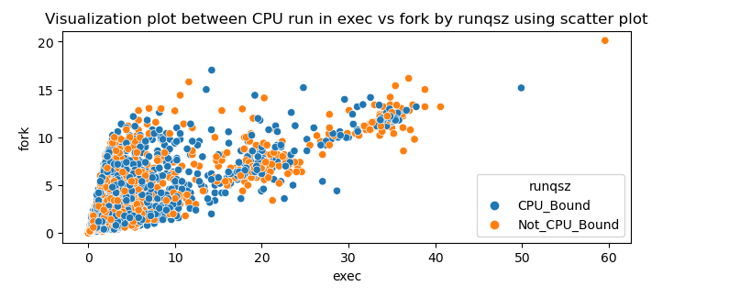
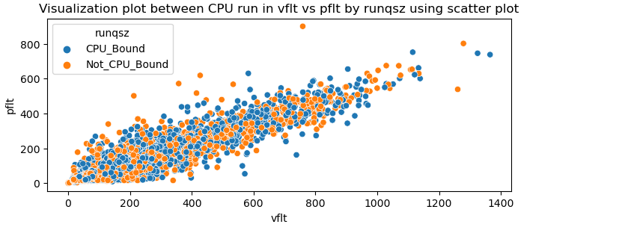

Mutivariate Analysis - Visualization using pairplot and Heat Map

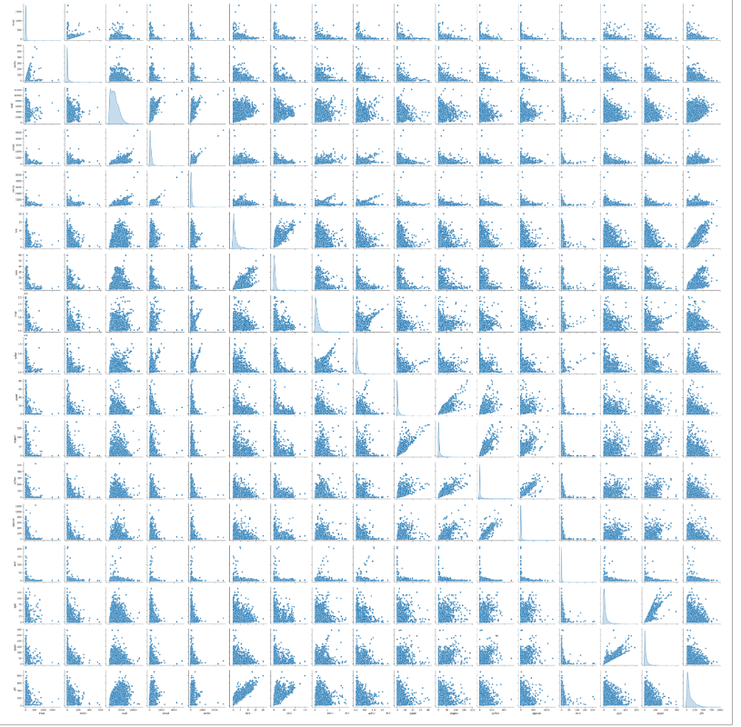

Heat Map
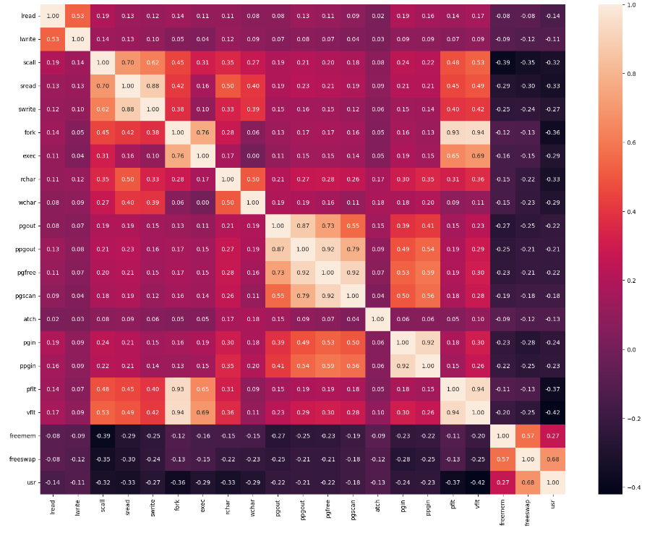
1.2 Impute null values if present, also check for the values which are equal to zero. Do they have any meaning or do we need to change them or drop them? Check for the possibility of creating new features if required. Also check for outliers and duplicates if there.
Solution:

Replace the null value with median function
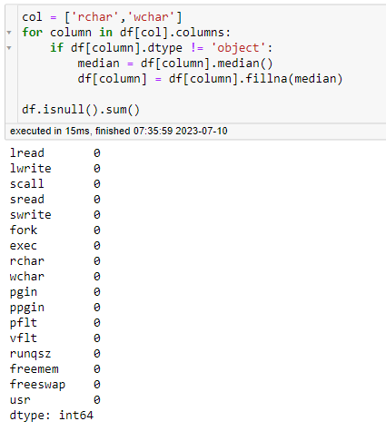
To check for the values which are equal to Zero.
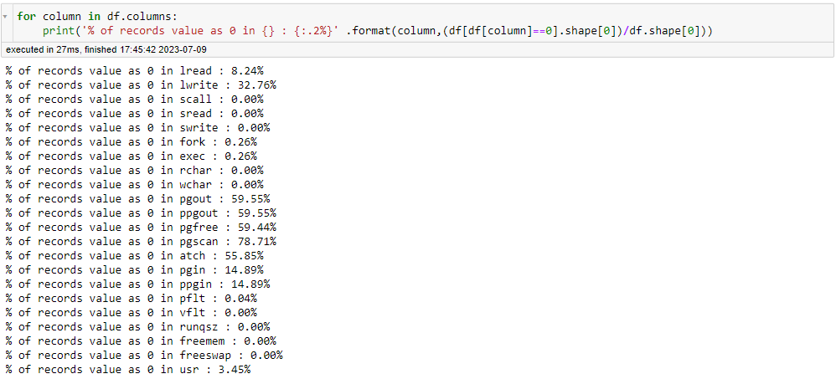
Drop function is used to drop columns and check the dataset using head function
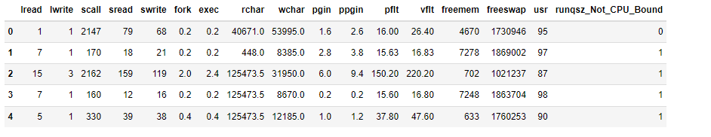
Replace remaining zero value by median function
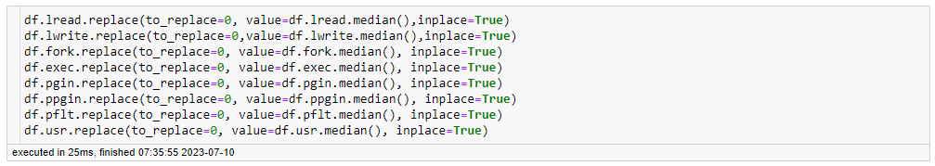
Shape function:
No. of rows: 8192 No of columns: 17

Summary:
- Null value is replaced by the median value for rchar & wchar in the dataset.
- The variables columns pgout, ppgout, pgfree, pgsan and atch having more than 50% of the values Zero.
- We drop the columns in having more than 50% of values having Zero. The variable columns is dropped from the dataset and columns details are pgout,ppgout,pgfree, pgscan and atch.
- The remaining variables columns lread, lwrite, fork, exec, pgin, ppgin, usr and pflt are having less than 50 % values of 0, need to be clean up the columns.
- Treat the columns is having minimum values of 0 with replace value using median function.
- There are 8192 number of rows and 17 columns in the dataset.
- There are 8 in int64, 8 in float64 and 1 object preset in the dataset.

Visualization of the Boxplot to check the outlier present in the dataset.
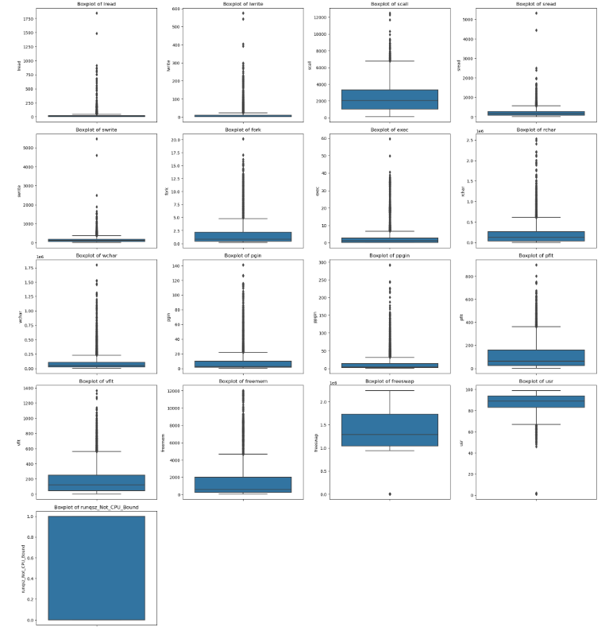
Summary:
- Yes outliers have been detected in all items. These outliers value need to be treated by replacing the value using the IQR.

Visualization of Boxplot after treating outliers.
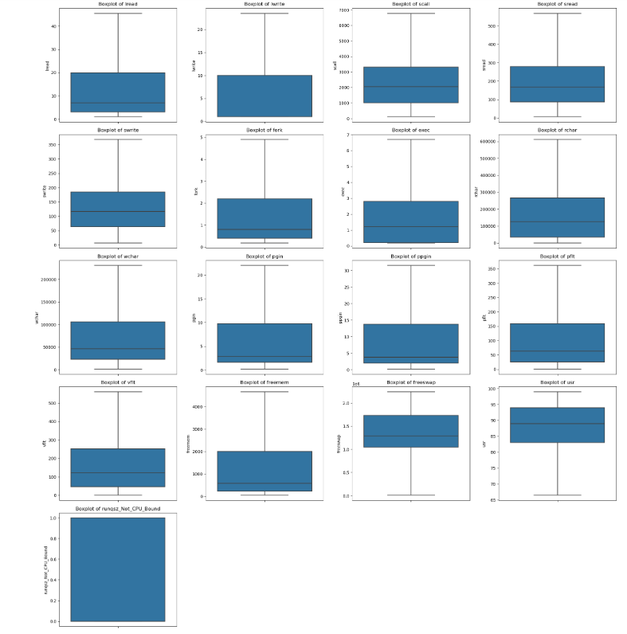

  - Encode the data (having string values) for Modelling. Split the data into train and test (70:30). Apply Linear regression using scikit learn. Perform checks for significant variables using appropriate method from statsmodel. Create multiple models and check the performance of Predictions on Train and Test sets using Rsquare, RMSE & Adj Rsquare. Compare these models and select the best one with appropriate reasoning.
Solution:
Linear Regression Model
Linear Regression using stats model (OLS)
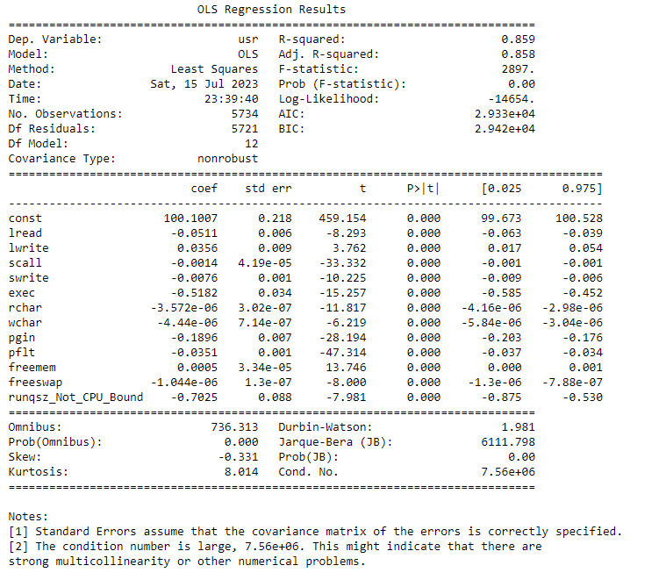
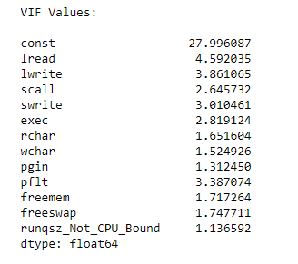

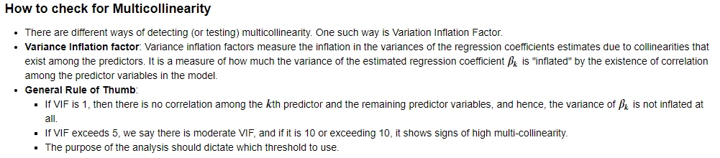

Linear Regression using Sklearn
LinearRegression()

Intercept Model
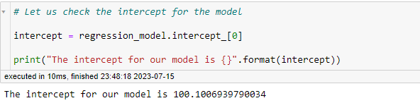

Coefficients for the each of the independent attribute.
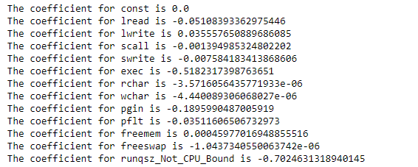

Linear Regression Equation :
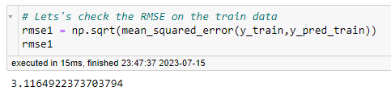
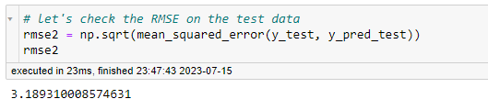

Summary:
- The R-squared value tells us that our model can explain .859 % of the variance in the training set.
- The Adj R-squared value tells us that our model can explain . 858% of the variance in the training set.
- Thre RMSE training data having value of 3.116 and RMSE test data having Value of 3.189

Encode data by using dummy variable, Two modules are used to check Linear Regression using Scikit learn and statsmodel. Split the data as X and Y as usr column as the target variable.
Regression score in the train model and the test model are similar.
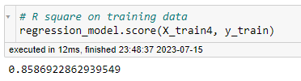
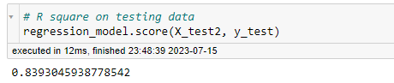
RMSE values in the Training and Testing are similar in both the model.
Statsmodel
Sklearn

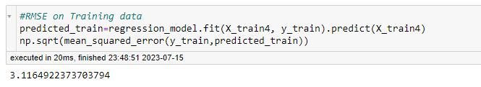
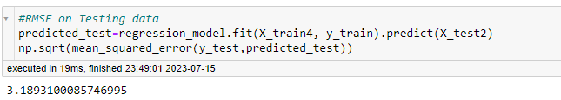

1.4 Inference: Basis on these predictions, what are the business insights and recommendations.

- We can see that RMSE on the train and test sets are comparable. So, our model is not suffering from overfitting
- MAE indicates that our current model is able to predict usr within a mean error of 2.3 units on the test data.
- Hence, we conclude the model ‘model5’ is good for prediction as well as inference purpose.

Problem 2: Logistic Regression, LDA and CART
You are a statistician at the Republic of Indonesia Ministry of Health and you are provided with a data of 1473 females collected from a Contraceptive Prevalence Survey. The samples are married women who were either not pregnant or do not know if they were at the time of the survey.
The problem is to predict do/don't they use a contraceptive method of choice based on their demographic and socio-economic characteristics.
Data Dictionary:
- Wife's age (numerical)
- Wife's education (categorical) 1=uneducated, 2, 3, 4=tertiary
- Husband's education (categorical) 1=uneducated, 2, 3, 4=tertiary
- Number of children ever born (numerical)
- Wife's religion (binary) Non-Scientology, Scientology
- Wife's now working? (binary) Yes, No
- Husband's occupation (categorical) 1, 2, 3, 4(random)
- Standard-of-living index (categorical) 1=verlow, 2, 3, 4=high
- Media exposure (binary) Good, Not good
- Contraceptive method used (class attribute) No,Yes

2.1 Data Ingestion: Read the dataset. Do the descriptive statistics and do null value condition check, check for duplicates and outliers and write an inference on it. Perform Univariate and Bivariate Analysis and Multivariate Analysis.

Head
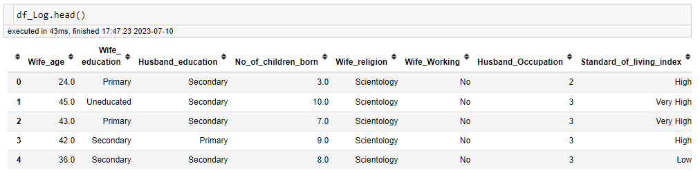

Info
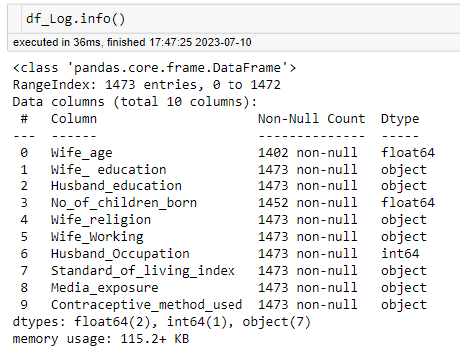

Checking Null Values Present
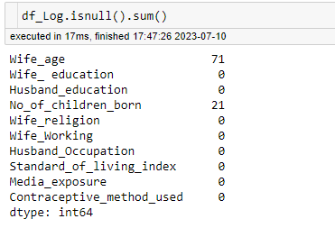

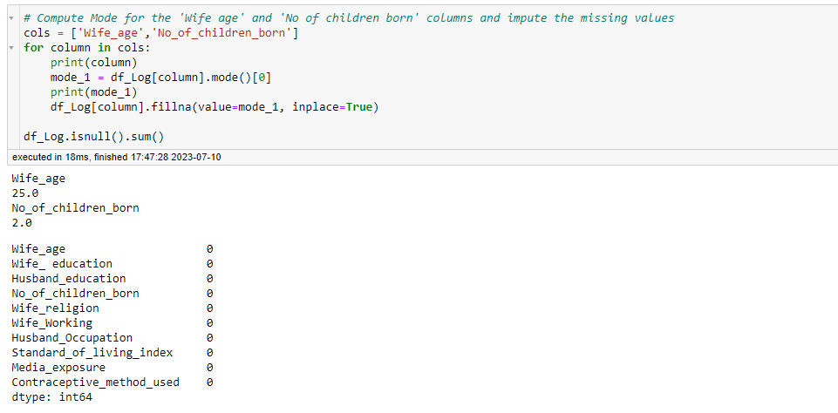
Check for Duplicate Values
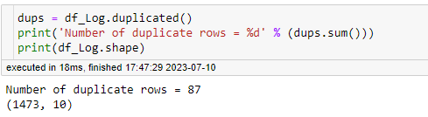
Drop Duplicate Values
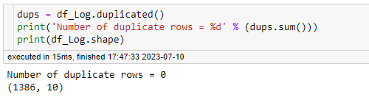
Describe
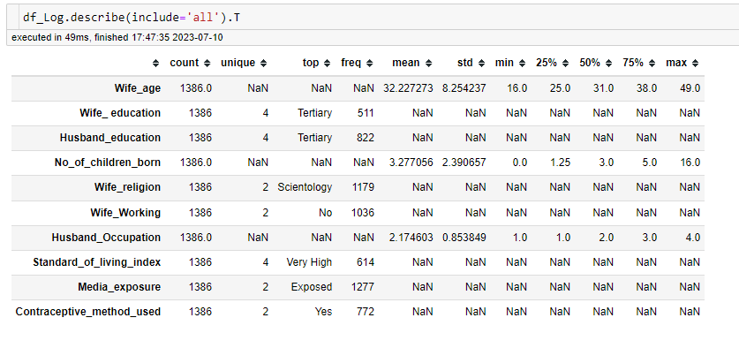

Summary:
- Checking the size of dataset using ‘.shape’ which provide the details number of rows and column, and ‘.info() gives the type of variables in the dataset and missing values present.
- There are 1473 number of rows and 10 columns in the dataset.
- There are 1 in int64, 2 in float64 and 7 in object present in the dataset.
- 80 Duplicate records are present in the dataset , which were dropped. After dropping duplicate records, No of rows were 1393 rows and 10 columns.
- Null values present in the dataset for wife_age having 71 rows and No of children born having 21 rows, these missing values were replaced with mode values.

Univariate Analysis
Categorical Feature
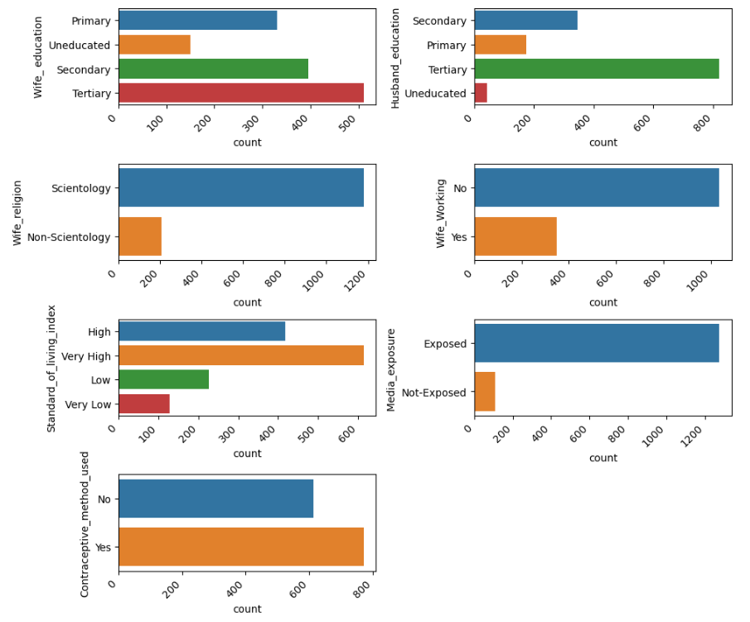

Summary:
Wife education and Husband education Tertiary are high, Wife Religion- Scientology is very high, Not Working Wife are more than Thousand compared with Working Wife is less than 400. Media Exposed are higher and Usage of Contraceptive is also higher side.
We will know the actuals when we compare the analysis in Bivariate model
Numeric Feature

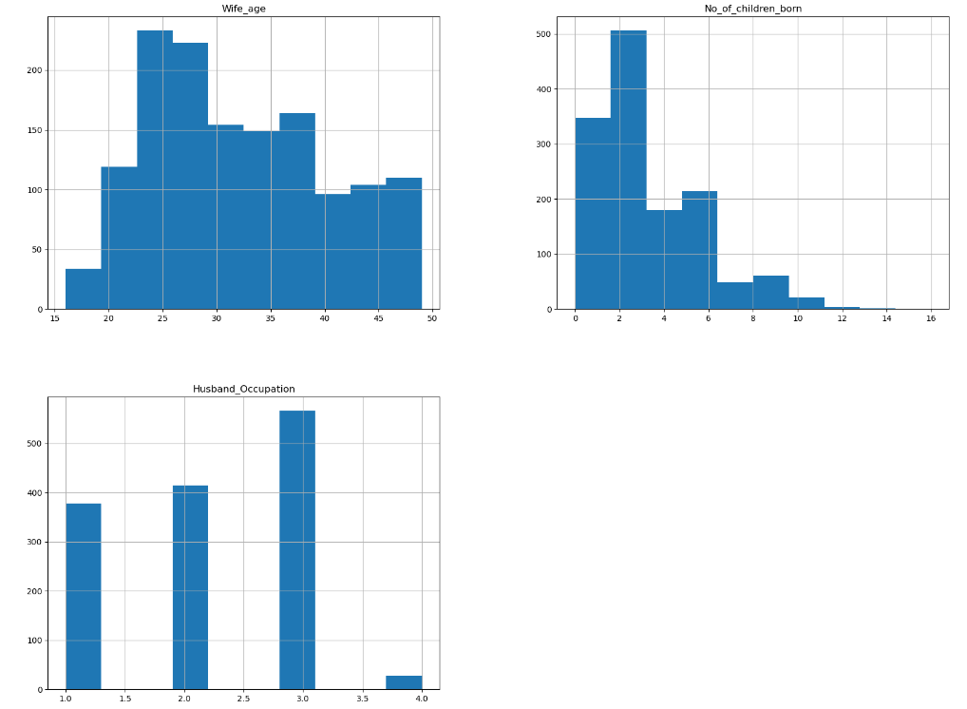

Bivariate Analysis

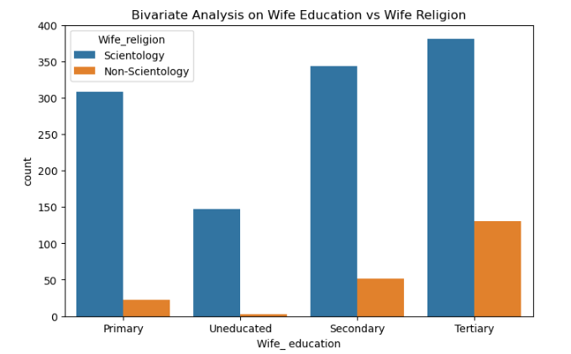

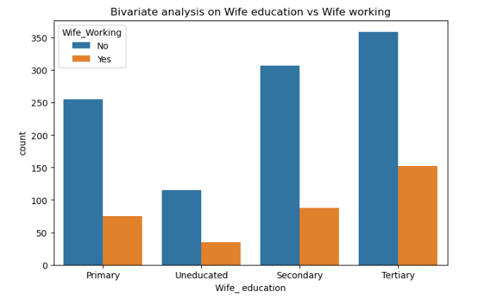
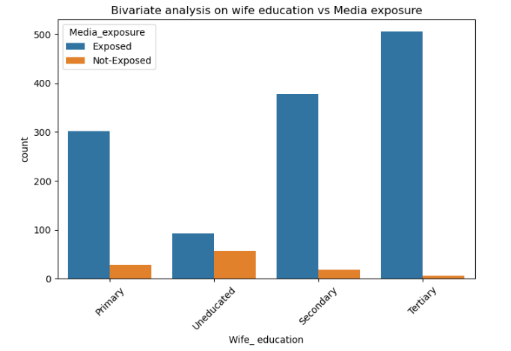
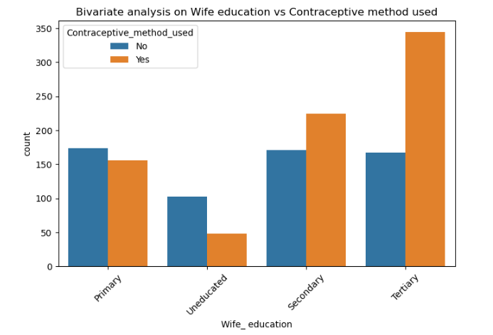
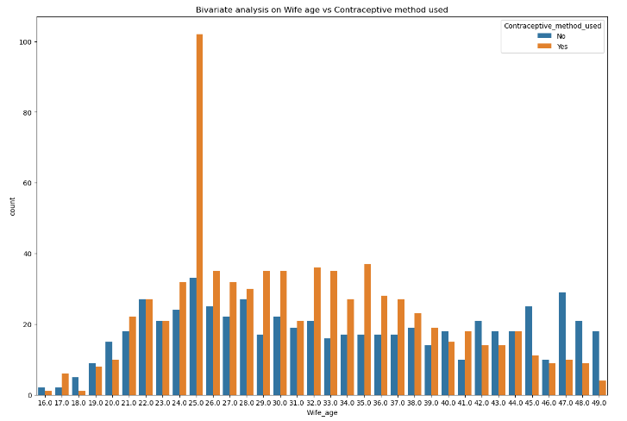

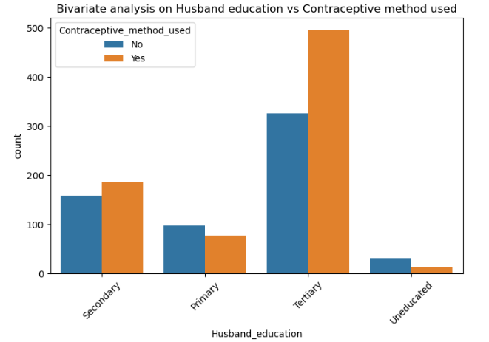

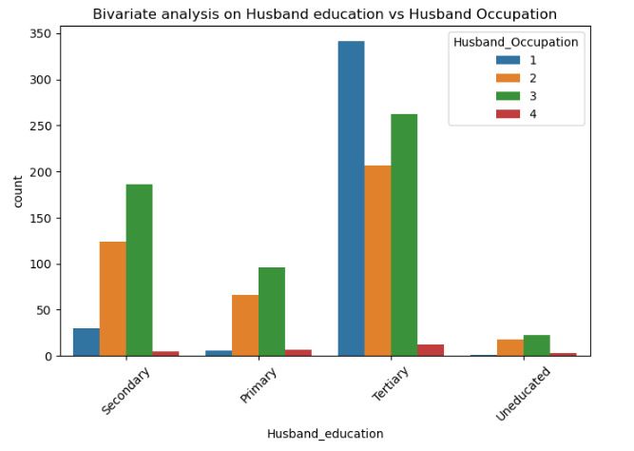

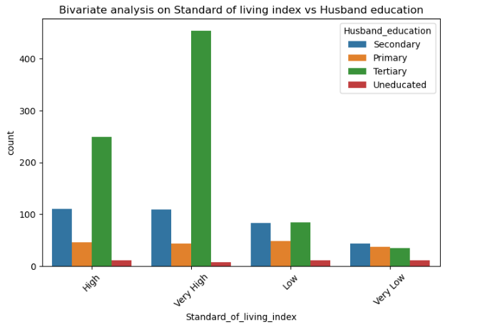

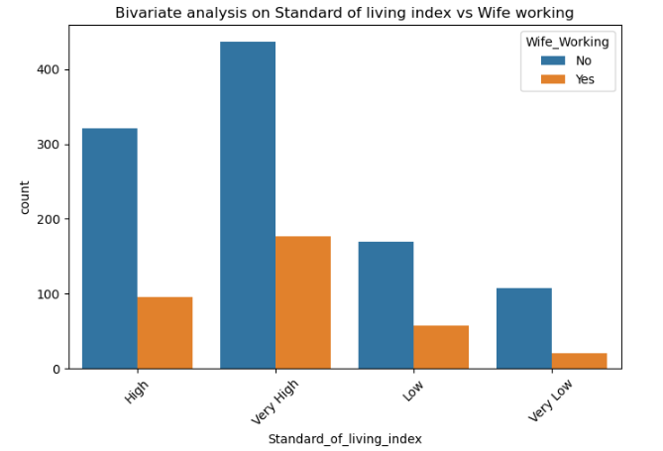

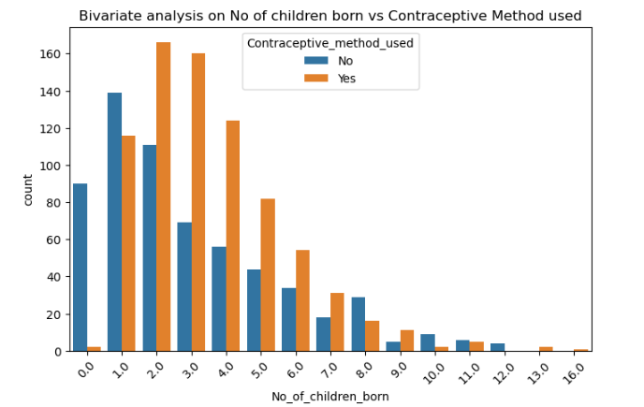

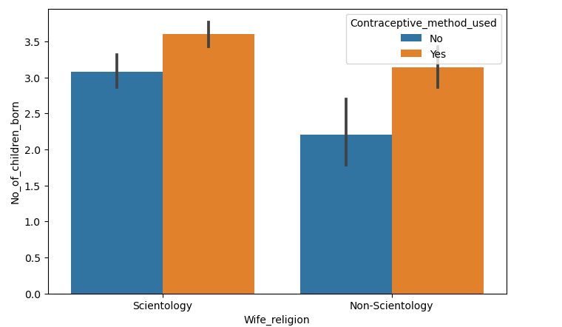

Multivariate Analysis

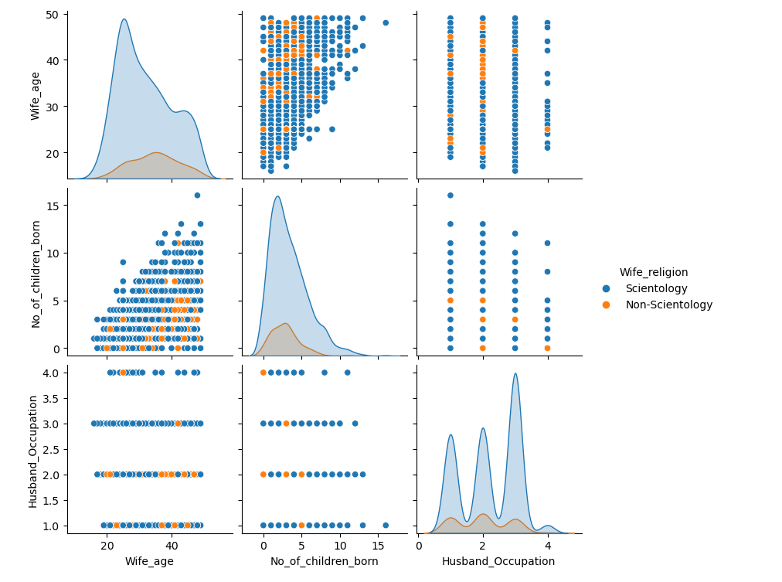

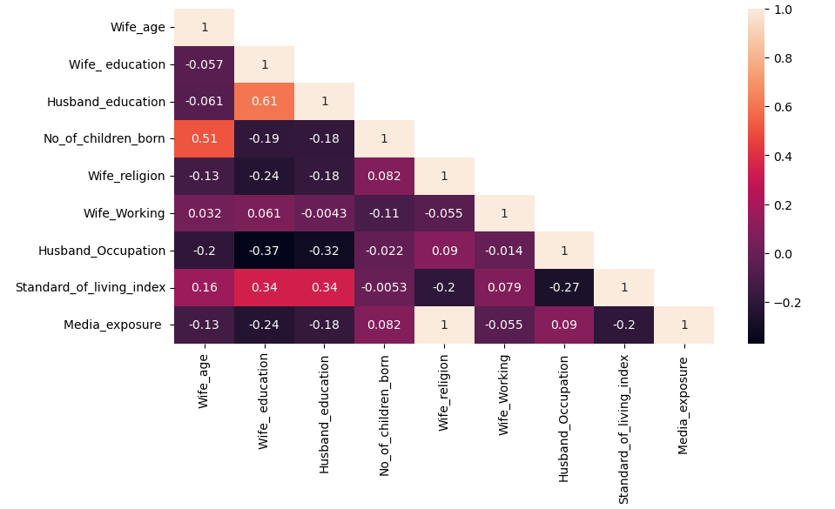

Outlier Treatment

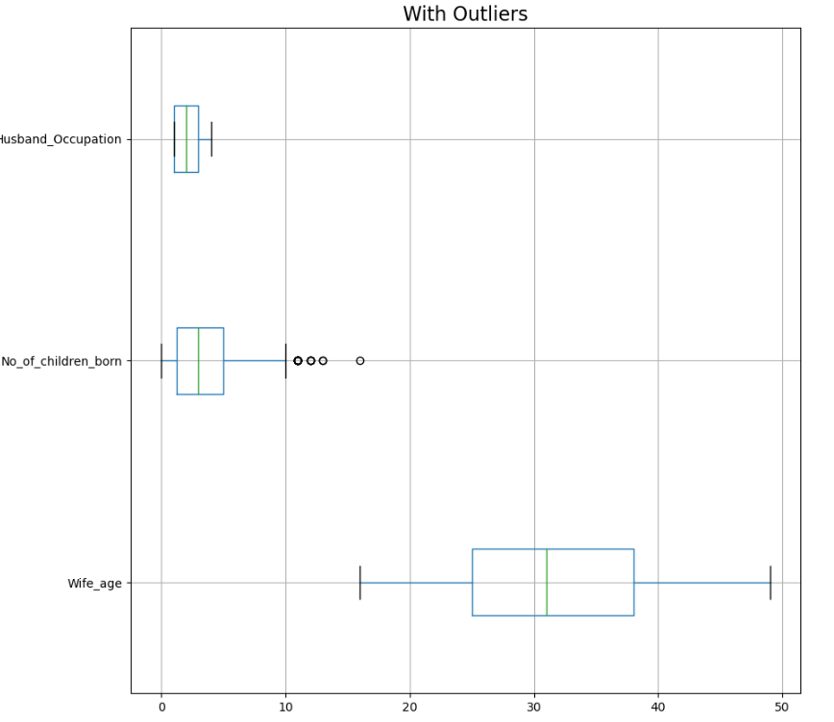
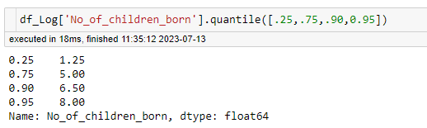

- No Outlier treatment performed

2.2 Do not scale the data. Encode the data (having string values) for Modelling. Data Split: Split the data into train and test (70:30). Apply Logistic Regression and LDA (linear discriminant analysis) and CART

Ans: Encoded the Categorical variables Wife_edcuation, Husband_education, Wife_religion, Standard_of_living_index, Media_exposure in
the ascending order from worst to best. Below is the encoding for ordinal values:

Wife education: Uneducated = 1, Primary = 2, Secondary = 3, Tertiary = 4.
Husband education: Uneducated = 1, Primary = 2, Secondary = 3, Tertiary = 4.
Wife religion: Non-Scientology = 0, Scientology = 1
Wife working: No = 0, Yes = 1
Standard of Living Index: Very Low = 1, Low = 2, High = 3, Very High = 4
Media Exposure: Not-Exposed = 0, Exposed = 1

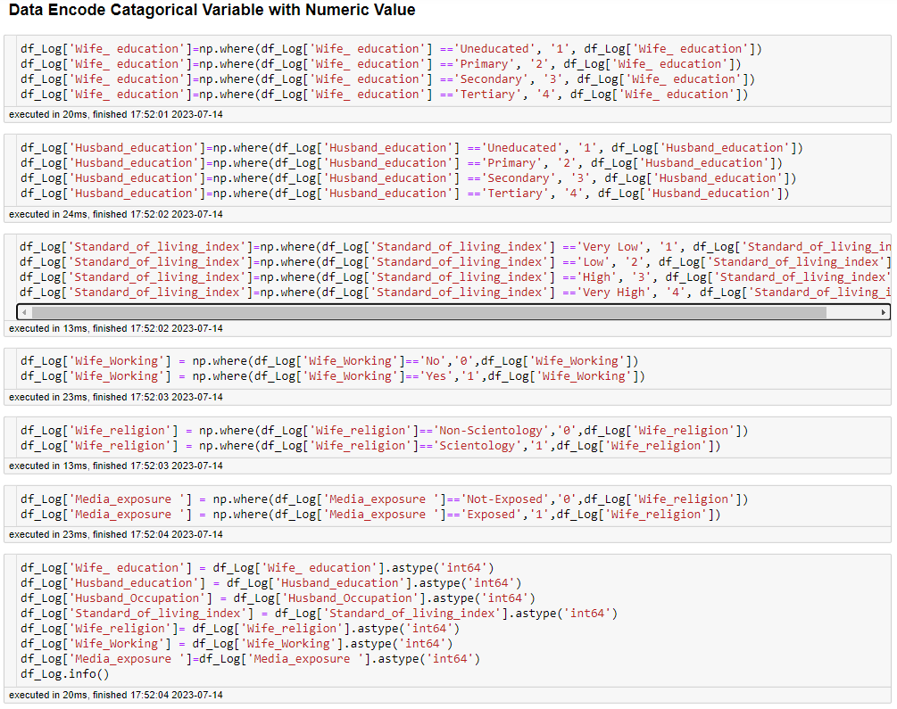

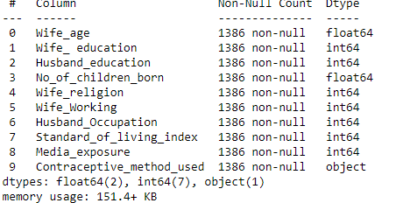

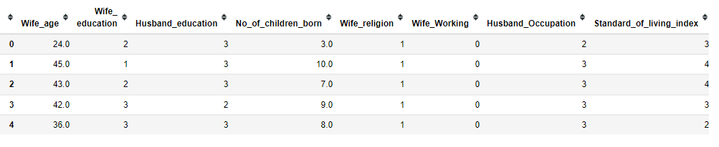

Logistic Regression
Fit the Logistic Regression model
Generate the Predicted Classes and Probability

Training Data Probability Prediction:
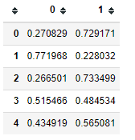
Testing Data Probability Prediction:
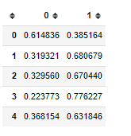

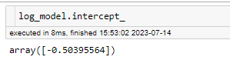

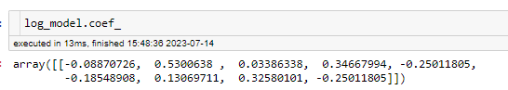

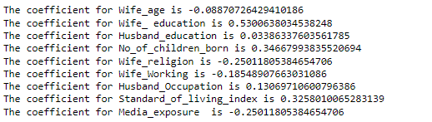

Applying GridSearchCV for Logistic Regression
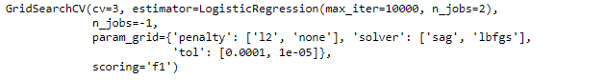
Training Data Probability Prediction:
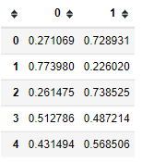

Testing Data Probability Prediction:
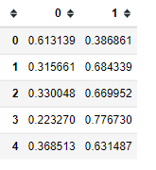

Linear Discriminant Analysis (LDA)
LinearDiscriminantAnalysis()

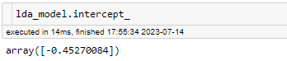

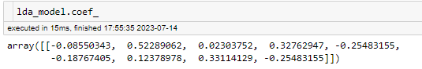
Training Data Probability Prediction:
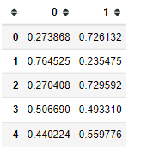
Testing Data Probability Prediction:
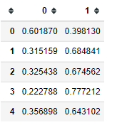

CART Model
DecisionTreeClassifier()

Training Data Probability Prediction:
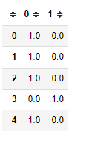
Testing Data Probability Prediction:
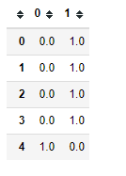
Decision Tree
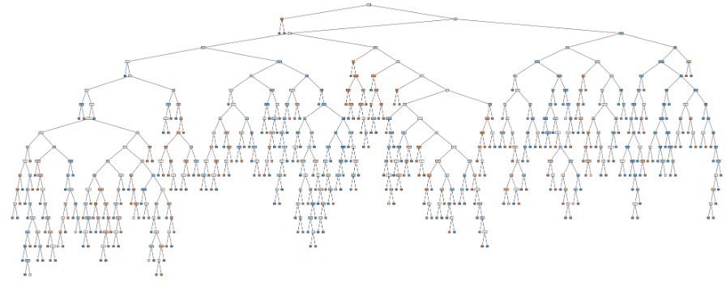

Decision Tree using GridSearchCV

Training Data Probability Prediction:
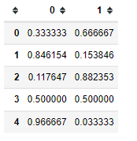
Testing Data Probability Prediction:
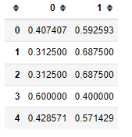
Pruned Decision Tree

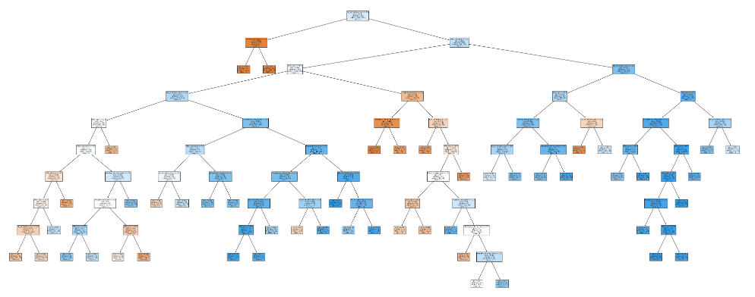

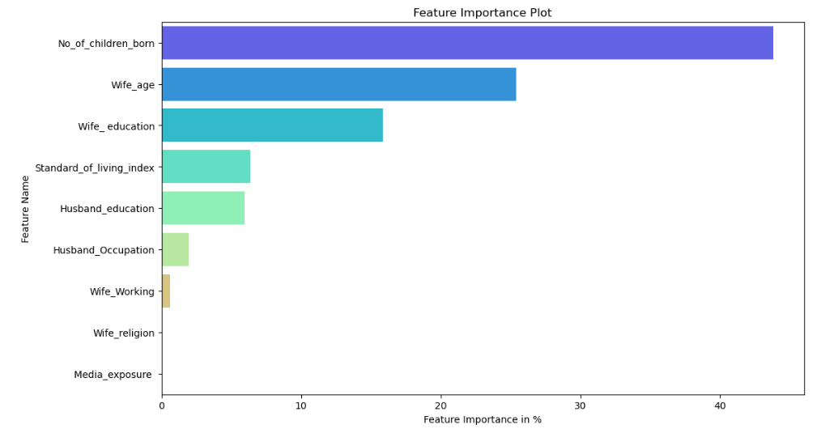

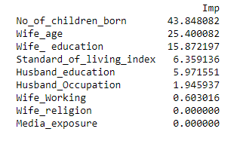

2.3 Performance Metrics: Check the performance of Predictions on Train and Test sets using Accuracy, Confusion Matrix, Plot ROC curve and get ROC_AUC score for each model Final Model: Compare Both the models and write inference which model is best/optimized.

Logistic Regression Confusion Matrix , Classification Report, ROC_AUC Score & ROC curve plot
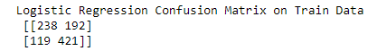
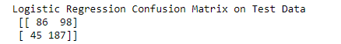

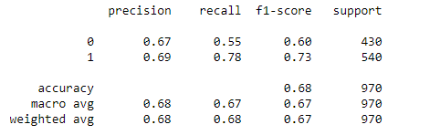

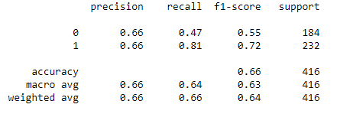

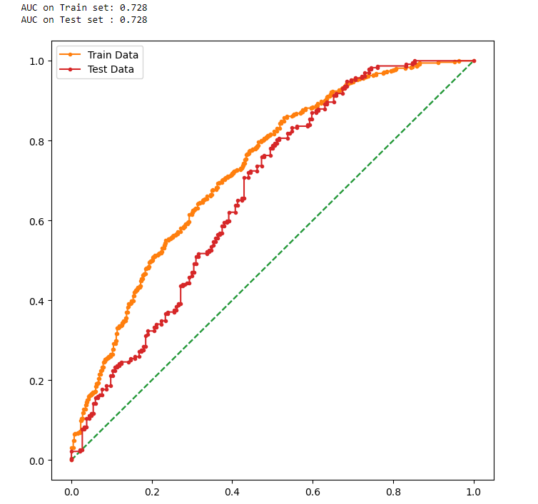

Summary:
- The confusion matrix and classification report for test data
- The precision is having 66% and recall is having 47% for the Contraceptive Method used label is 0
- The precision is having 66% and recall is having 81% for the Contraceptive Method used label is 1
- The overall accuracy is having 66%
- The confusion matrix and classification report for train data
- The precision is having 67% and recall is having 55% for the Contraceptive Method used label is 0
- The precision is having 69% and recall is having 78% for the Contraceptive Method used label is 1
- The overall accuracy is having 68%

Linear Discriminant Analysis Confusion Matrix , Classification Report, ROC AUC Score and ROC Curve
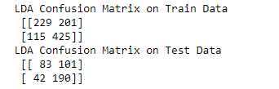

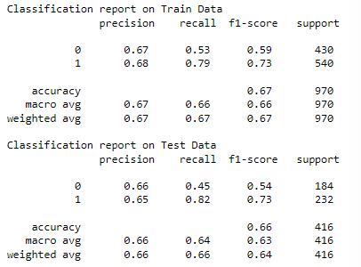

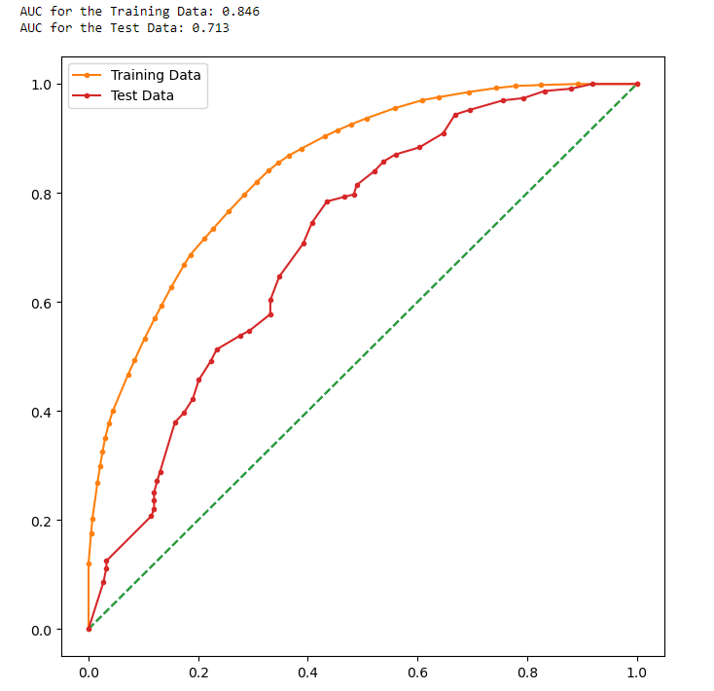

Summary:
- The confusion matrix and classification report for training data
- The precision is having 67% and recall is having 53% for Contraceptive Method used label is 0
- The precision is having 68% and recall is having 79% for Contraceptive Method used label is 1
- The overall accuracy is 67%
- The confusion matrix and classification report for test data
- The precision is having 66% and recall is having 45% for Contraceptive Method used label is 0
- The precision is having 65% and recall is having 82% for Contraceptive Method used label is 1
- The overall accuracy is 66%

CART Model Confusion Matrix , Classification Report, ROC AUC Score and ROC Curve
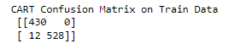

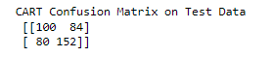

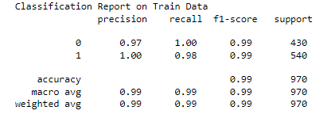
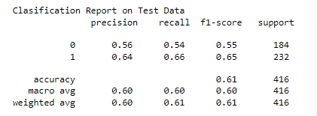

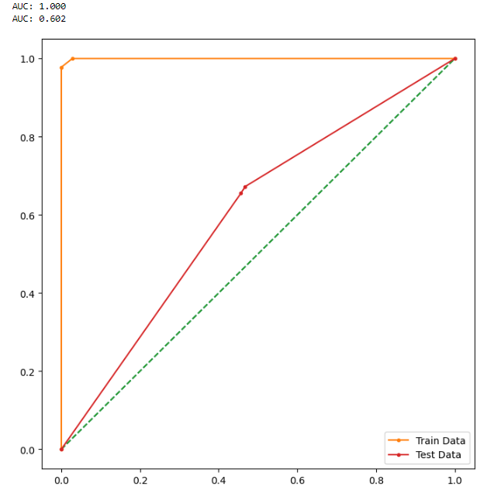

- The Accuracy score in the training set is 99% and the accuracy score in the test set 61%
- The difference between the train set and test set is more than 10%.
- The training set data is overfitting.

DecisionTreeClassifier using GridSearch CV
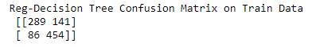
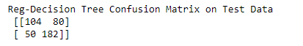
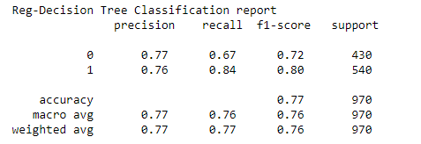

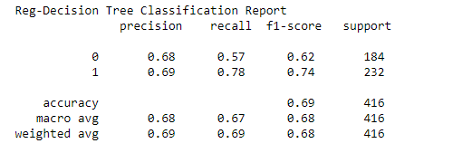

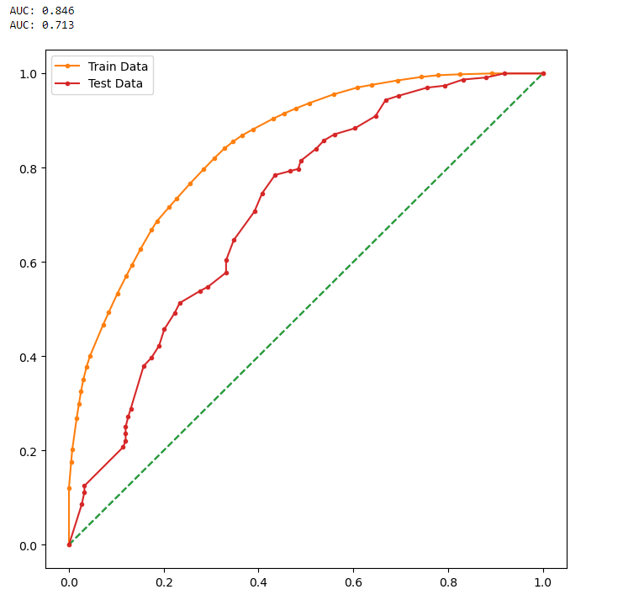
Summary:
- The confusion matrix and classification report for training data
- The precision is having 77% and the recall is having 67% for Contraceptive Method Used label is 0
- The precision is having 76% and recall is having 84% for Contraceptive Method Used label is 1
- The overall accuracy is having 77%
- The confusion matrix and classification report for test data
- The precision is having 68% and recall is having 57% for Contraceptive Method Used label is 0
- The precision is having 69% and recall is having 78% for Contraceptive Method Used label is 1
- The overall accuracy is having 69%
- Husband Occupation , Wife religion, Wife working and Media exposure features are not required, since the values is only 2%
Can be dropped and the Remain feature is contributing near 98%

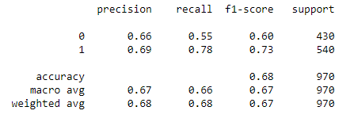
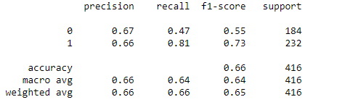

Comment:

2.4 Inference: Basis on these predictions, what are the insights and recommendations.
Please explain and summarise the various steps performed in this project. There should be proper business interpretation and actionable insights present.

Ans: The EDA analysis clearly indicates that women with tertiary education and very high standard of living contraceptive methods Women ranging from 21 to 38 generally use contraceptive methods more
The usage of contraceptive methods need not depend on the demographic or socioeconomic backgrounds since the use of contraceptive methods were almost the same for both working and non working women
The use of contraceptive method was high for both scientology and Non-scientology women.

